Nanopore Rapid DNA Library Prep (SQK-RAD114) – MS-CB ANGSD 2025
Prepared by Theodore M. Nelson
Name: _______________________ CWID: _______________________

Introduction
In today’s lab, you will prepare a DNA sequencing library from wastewater DNA, generated in collaboration with GRAVL, Inc, 55 Court Street, 2nd floor, Boston, MA 02108 and collected in Washington State. We will be using Oxford Nanopore’s Rapid Sequencing Kit V14 (SQK-RAD114). This kit is designed for rapid tagmentation and adapter ligation with minimal equipment. This protocol is PCR-free and does not require third-party ligase.

Sample Metadata Table [Submitted]
# | Sample ID | 260/280 | Conc. (ng/µL) | Volume for 100 ng | Storage | Notes
1 | WWTP_A | ___ | ___ | ___ µL | -20°C | ___
2 | WWTP_B | ___ | ___ | ___ µL | -20°C | ___
3 | WWTP_C | ___ | ___ | ___ µL | -20°C | ___
Q1: What does each wavelength within the 260 / 280 measure?

Sample Quality Control
Before loading a Nanopore flow cell, we perform our own quality control analysis. Below is an example trace from a Fragment Analyzer run of Sample 626157-6. This chart provides a detailed profile of DNA fragment sizes and relative concentrations across the sample.
This type of analysis is critical before performing long-read Nanopore sequencing. The trace shows many short fragments (~100–600 bp), which make up over 40% of the sample according to the smear analysis. These short fragments present two major challenges for Nanopore sequencing:
1. Size-exclusion bias: Nanopore sequencing preferentially loads shorter fragments if they are present in high abundance, which can reduce sequencing efficiency and read length distribution.
2. Input concentration risk: While SPRI bead-based size selection could reduce short fragments, it may result in a significant loss of total DNA, which could leave some samples below the input requirement for sequencing.
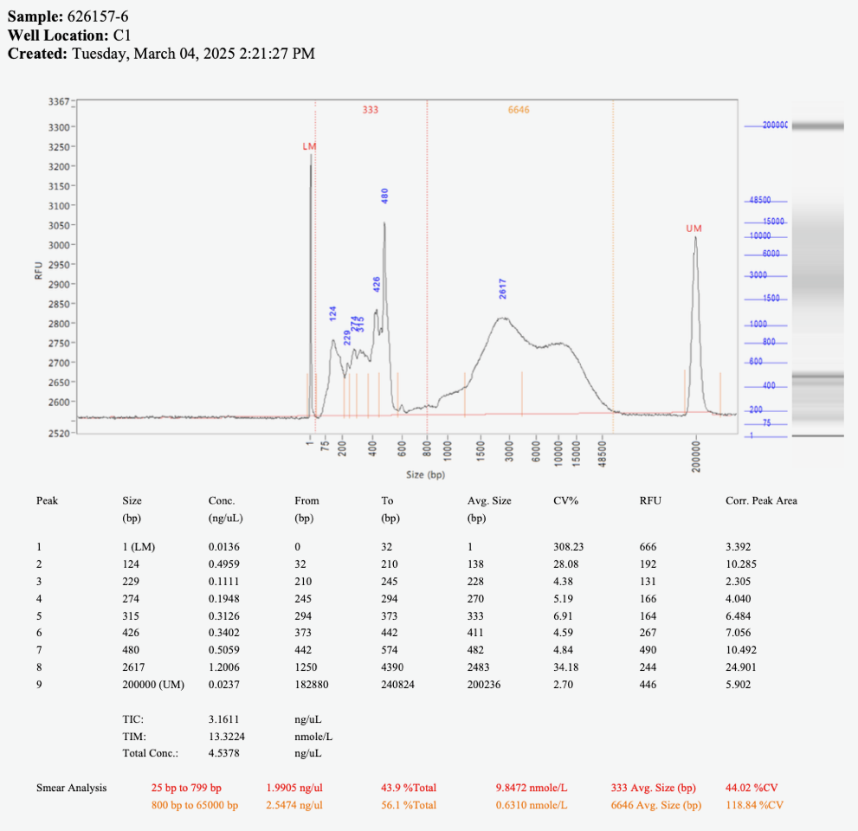

Library Preparation Protocol (SQK-RAD114)
1. Prepare Input DNA:
- Transfer 100–150 ng of genomic DNA into a 1.5 ml DNA LoBind tube.
- Adjust to 10 µl with nuclease-free water.
- Mix by flicking and spin down.
2. Tagmentation:
- Add 10 µl DNA + 1 µl Fragmentation Mix (FRA) → Total: 11 µl.
- Incubate: 30°C for 2 min, then 80°C for 2 min.
- Cool on ice.
3. Adapter Ligation:
- Mix 1.5 µl RA + 3.5 µl ADB to prepare RA mix.
- Add 1 µl to the 11 µl tagmented DNA.
- Incubate 5 min at room temperature.
- Keep on ice.
Q2: What is the purpose of the tagmentation step in the context of metagenomic samples from wastewater?

Flow Cell Priming & Loading (MinION/GridION)
- Prepare Priming Mix (per flow cell):
- 1,170 µl Flow Cell Flush (FCF)
- 30 µl Flow Cell Tether (FCT)
- 5 µl BSA (50 mg/ml)

- Load 800 µl of the mix into the flow cell. Wait 5 minutes.

- Prepare Loading Mix:
- 37.5 µl Sequencing Buffer (SB)
- 25.5 µl Library Beads (LIB)
- 12 µl DNA library
- Load 75 µl into the SpotON port dropwise.
Q3: Why is it important to avoid air bubbles when loading a flow cell? What can go wrong?

Sequencing Setup in MinKNOW
1. Open MinKNOW and start a new experiment.
2. Select SQK-RAD114 kit.
3. Monitor in real-time.
4. Use EPI2ME if desired.
Q4: What types of organisms or genes might you expect to detect from wastewater sequencing? How might this support public health monitoring?

Post-Run QC and Flow Cell Reuse
Follow the Flow Cell Wash Kit protocol to reuse or return your flow cell.
Q5: Why is it important to wash the flow cell shortly after use, and what could happen if it's delayed?

Critical Thinking Questions
1. What are some potential contaminants found in wastewater DNA samples that might interfere with sequencing?
2. Describe a computational method you could use to filter host (human) DNA reads post-sequencing.
3. If your read N50 is <500 bp, what might be the cause?
4. What is the advantage of Nanopore's long-read sequencing for environmental DNA compared to short-read platforms?

Additional Notes / Observations
Record any changes to the protocol, observations during library prep, issues during flow cell loading, or anomalies in MinKNOW readout here:
____________________________________________________________________
____________________________________________________________________
____________________________________________________________________
____________________________________________________________________
____________________________________________________________________

